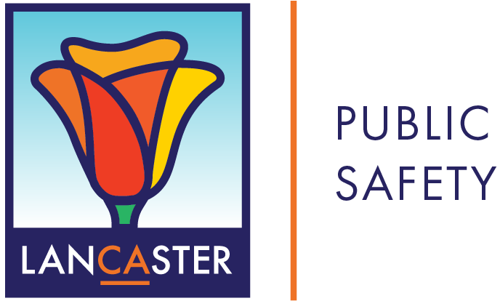

**Family Agreement Form**

**As your parent:**

I promise to talk with you and answer your questions about the risks and dangers of drinking alcohol and using other drugs. I will create an alcohol- and drug-free environment that is safe for you and your friends. I promise to pick you up at any time or place if you find yourself in an uncomfortable situation where underage drinking or other drug use is involved.

By signing this form, I agree to help keep you alcohol- and drug-free.

**As your child:**

I understand that drinking alcohol and using other drugs is harmful to my health and can make me say or do things I might regret. I will do my best to avoid situations where my friends and others are drinking alcohol or using other drugs. I promise to call or text you to help get me out of situations where alcohol and other drugs are being used.

By signing this form, I agree to not drink alcohol or use other drugs.

Parent Signature Child Signature